**Movies Review website project**

**Main idea**

A website that contains some trending movies, including the trailer, a brief overview, the cast and the rating of each one of them from several ratings websites such as ( rottentomatoes, imdb, metacritic and letterboxd). The user is able to register and create an account on our website

This website is made by using the programming languages : HTML, CSS and Javascript for the frontend . And ASP.net , sql server for the backend

**ER diagram**

**Some snapshots from the website**

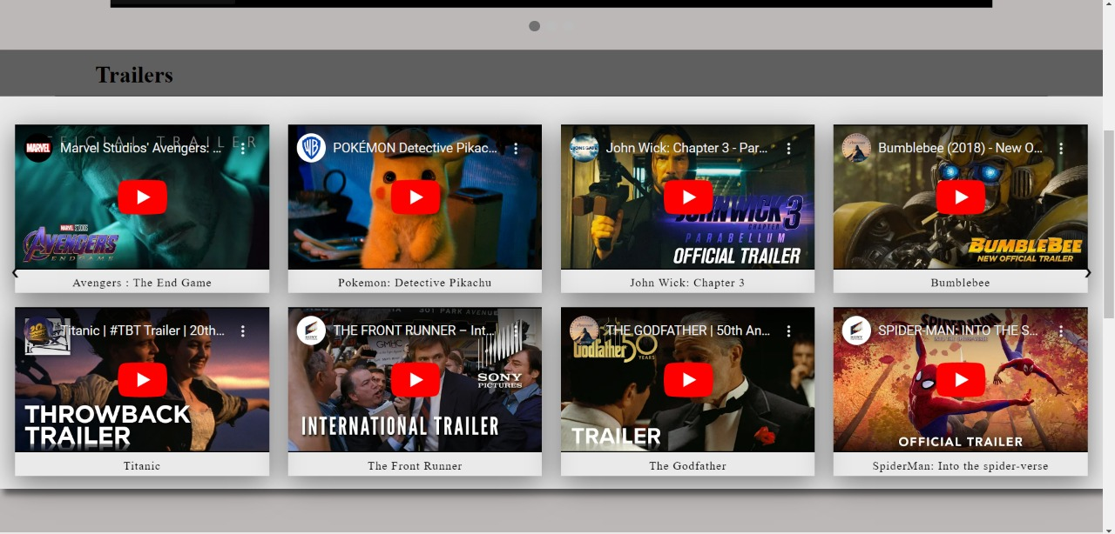

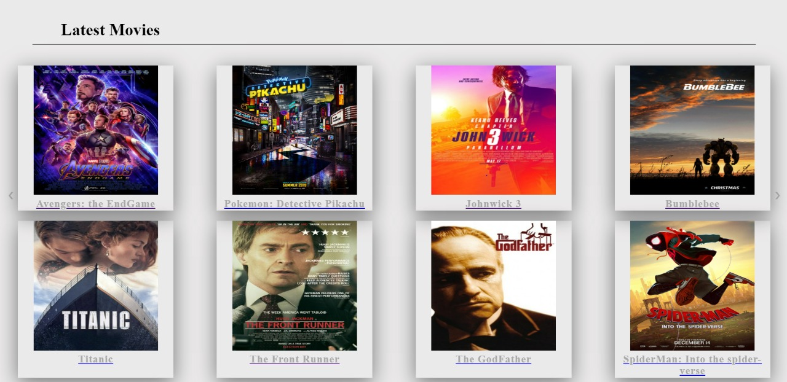

**Sample code of the home page**

<%@ Page Language="C#" AutoEventWireup="true" CodeBehind="HomePage.aspx.cs" Inherits="Project_web_dev.HomePage" %>

<!DOCTYPE html>

<html xmlns="http://www.w3.org/1999/xhtml">

<head runat="server">

<title>HomePage(MovieVerse)</title>

<link rel="stylesheet" href="HomePage.css"/>

<style>

body {

margin: 0;

padding: 0;

box-sizing: border-box;

background-color: #bdb8b8;

}

.topnav {

background-color: #333;

overflow: hidden;

}

.topnav a {

float: left;

color: #f2f2f2;

text-align: center;

padding: 14px 16px;

text-decoration: none;

font-size: 17px;

}

.topnav a:hover {

background-color: #ddd;

color: black;

}

.topnav a.active {

background-color: black;

color: white;

}

* {

box-sizing: border-box

}

.slideshow-container {

right: 100%;

width: 80%;

height: 450px;

margin: auto;

}

.mySlides {

display: none;

}

.prev, .next {

cursor: pointer;

position: fixed;

top: 50%;

width: auto;

margin-top: -22px;

padding: 16px;

color: rgb(10, 10, 10);

font-weight: bold;

font-size: 18px;

transition: 0.6s ease;

border-radius: 0 3px 3px 0;

user-select: none;

}

.prev {

left: 0;

}

.next {

right: 0;

border-radius: 3px 0 0 3px;

}

.prev:hover, .next:hover {

background-color: rgba(0,0,0,0.8);

}

.text {

color: #080808;

font-size: 30px;

font-weight: bold;

padding: 20px 5px;

position: absolute;

bottom: 18px;

width: 100%;

text-align: end;

}

.numbertext {

color: #000000;

font-size: 12px;

padding: 8px 12px;

position: absolute;

top: 0;

}

.dot {

cursor: pointer;

height: 15px;

width: 15px;

margin: 0 2px;

background-color: #bbb;

border-radius: 50%;

display: inline-block;

transition: background-color 0.6s ease;

}

.active, .dot:hover {

background-color: #717171;

}

.fade {

animation-name: fade;

animation-duration: 1.5s;

}

@keyframes fade {

from {

opacity: .4

}

to {

opacity: 1

}

}

.trailer_container {

background: rgba(248, 248, 240, 0.7);

background: rgba(17, 16, 16, 0.5);

background: rgba(255,255,255,0.7);

margin-bottom: 0;

box-shadow: 5px 8px 8px rgba(0,0,0,0.5);

}

.trailer_header {

background: rgba(37, 36, 36, 0.7);

}

.trailer_header h1 {

font-weight: bold;

padding: 15px 0 10px 55px;

position: relative;

left: 5%;

border-bottom: 1px solid rgba(0,0,0,0.5);

width: 90%;

}

.trailer_content {

display: grid;

grid-template-columns: repeat(auto-fit, minmax(350px, 1fr));

grid-gap: 20px;

margin: 20px auto 60px;

padding: 18px;

}

.trailer {

position: relative;

width: 350px;

margin: 0 auto;

box-shadow: 0 10px 40px rgba(0,0,0,0.5);

overflow: hidden;

text-align: center;

}

.trailer iframe {

width: 100%;

height: 200px;

}

.trailer .caption {

padding: 5px;

letter-spacing: 1px;

font-weight: 400;

}

.latest_movies_container {

background: rgba(248, 248, 240, 0.7);

background: rgba(17, 16, 16, 0.5);

background: rgba(255,255,255,0.7);

width: 102%;

position: relative;

left: -1%;

box-shadow: 5px 8px 8px rgba(0,0,0,0.5);

}

.latest_movies_content {

display: grid;

grid-template-columns: repeat(auto-fit, minmax(350px, 1fr));

grid-gap: 20px;

margin: 20px auto 60px;

padding: 18px;

padding-bottom: 35px;

}

.latest_movies_header h1 {

font-weight: bold;

padding: 45px 0 10px 55px;

position: relative;

left: 5%;

border-bottom: 1px solid rgba(0,0,0,0.5);

width: 90%;

}

.latest_movies {

position: relative;

width: 300px;

text-align: center;

margin: 0 auto;

box-shadow: 0 10px 40px rgba(0,0,0,0.5);

overflow: hidden;

}

.latest_movies a .caption {

text-decoration: none;

}

.latest_movies img.photo {

width: 80%;

max-height: 250px;

transition: 0.5s;

}

.latest_movies img.photo:hover {

transform: scale(1.2);

}

.latest_movies .caption {

font-size: 20px;

font-weight: bold;

color: rgb(170, 170, 170);

padding: 2px 0;

letter-spacing: 1px;

}

</style>

</head>

<body>

<form id="form1" runat="server">

<div>

<div class="topnav">

<a class="active" href="HomePage.aspx">HomePage</a>

<a href="#news">Trailer</a>

<a href="#contact">Trending</a>

<a style="margin-left: 28cm;" href="RegisterPage.aspx">Sign Up</a>

<a style="margin-right: -25cm;" href="LoginPage.aspx">Login</a>

</div>

<div class="slideshow-container">

<div class="mySlides fade">

<div class="numbertext"></div>

<iframe src="https://www.youtube.com/embed/TcMBFSGVi1c" style="width:100%" height="450px" frameborder = "0" allowfullscreen controls = "" ></iframe>

</div>

<div class="mySlides fade">

<div class="numbertext"></div>

<iframe src="https://www.youtube.com/embed/1roy4o4tqQM" style="width:100%" height="450px" frameborder = "0" allowfullscreen controls = "" ></iframe>

</div>

<div class="mySlides fade">

<div class="numbertext"></div>

<iframe src="https://www.youtube.com/embed/M7XM597XO94" style="width:100%" height="450px" frameborder = "0" allowfullscreen controls = "" ></iframe>

</div>

<a class="prev" onclick="plusSlides(-1)">&#10094;</a>

<a class="next" onclick="plusSlides(1)">&#10095;</a>

</div>

<br>

<div style="text-align:center">

<span class="dot" onclick="currentSlide(1)"></span>

<span class="dot" onclick="currentSlide(2)"></span>

<span class="dot" onclick="currentSlide(3)"></span>

</div>

<script>

let slideIndex = 1;

showSlides(slideIndex);

function plusSlides(n) {

showSlides(slideIndex += n);

}

function currentSlide(n) {

showSlides(slideIndex = n);

}

function showSlides(n) {

let i;

let slides = document.getElementsByClassName("mySlides");

let dots = document.getElementsByClassName("dot");

if (n > slides.length) { slideIndex = 1 }

if (n < 1) { slideIndex = slides.length }

for (i = 0; i < slides.length; i++) {

slides[i].style.display = "none";

}

for (i = 0; i < dots.length; i++) {

dots[i].className = dots[i].className.replace(" active", "");

}

slides[slideIndex - 1].style.display = "block";

dots[slideIndex - 1].className += " active";

}

</script>

<div class = "main_body container-fluid">

<div class = "trailer_container row">

<div class = "trailer_header">

<h1>Trailers</h1>

</div>

<div class = "trailer_content">

<div class = "trailer">

<iframe src="https://www.youtube.com/embed/TcMBFSGVi1c" frameborder = "0" allowfullscreen controls = "" ></iframe>

<div class = "caption">

Avengers : The End Game

</div>

</div>

<div class = "trailer">

<iframe src="https://www.youtube.com/embed/1roy4o4tqQM" frameborder = "0" allowfullscreen controls = "" ></iframe>

<div class = "caption">

Pokemon: Detective Pikachu

</div>

</div>

<div class = "trailer">

<iframe src="https://www.youtube.com/embed/M7XM597XO94" frameborder = "0" allowfullscreen controls = "" ></iframe>

<div class = "caption">

John Wick: Chapter 3

</div>

</div>

<div class = "trailer">

<iframe src="https://www.youtube.com/embed/lcwmDAYt22k" frameborder = "0" allowfullscreen controls = "" ></iframe>

<div class = "caption">

Bumblebee

</div>

</div>

<div class = "trailer">

<iframe src="https://www.youtube.com/embed/CHekzSiZjrY" frameborder = "0" allowfullscreen controls = "" ></iframe>

<div class = "caption">

Titanic

</div>

</div>

<div class = "trailer">

<iframe src="https://www.youtube.com/embed/MDQd_gaMGoI" frameborder = "0" allowfullscreen controls = "" ></iframe>

<div class = "caption">

The Front Runner

</div>

</div>

<div class = "trailer">

<iframe src="https://www.youtube.com/embed/UaVTIH8mujA" frameborder = "0" allowfullscreen controls = "" ></iframe>

<div class = "caption">

The Godfather

</div>

</div>

<div class = "trailer">

<iframe src="https://www.youtube.com/embed/g4Hbz2jLxvQ" frameborder = "0" allowfullscreen controls = "" ></iframe>

<div class = "caption">

SpiderMan: Into the spider-verse

</div>

</div>

</div>

</div>

</div>

<div class = "latest_movies_container">

<div class="latest_movies_header">

<h1>Latest Movies</h1>

</div>

<div class="latest_movies_content">

<div class="latest_movies">

<div>

<a href ="Project Pages Pictures/Endgame.html" target = "_blank">

<img class = "photo" src="Project Pages Pictures/endgame.jpg">

<div class = "caption">

Avengers: the EndGame

</div>

</a>

</div>

</div>

<div class="latest_movies">

<div>

<a href ="Project Pages Pictures/pokemon.html" target = "_blank">

<img class = "photo" src ="Project Pages Pictures/pokemon.jpg">

<div class = "caption">

Pokemon: Detective Pikachu

</div>

</a>

</div>

</div><div class="latest_movies">

<div>

<a href ="Project Pages Pictures/John Wick.html" target = "_blank">

<img class = "photo" src ="Project Pages Pictures/johnwick.jpg">

<div class = "caption">

Johnwick 3

</div>

</a>

</div>

</div><div class="latest_movies">

<div>

<a href ="Project Pages Pictures/Bumblebee.html" target = "_blank">

<img class = "photo" src = "Project Pages Pictures/bum.jpg">

<div class = "caption">

Bumblebee

</div>

</a>

</div>

</div><div class="latest_movies">

<div>

<a href ="Project Pages Pictures/Titanic.html" target = "_blank">

<img class = "photo" src ="Project Pages Pictures/titanic.jpg">

<div class = "caption">

Titanic

</div>

</a>

</div>

</div><div class="latest_movies">

<div>

<a href ="Project Pages Pictures/The Front Runner.html" target = "_blank">

<img class = "photo" src ="Project Pages Pictures/front.jpg">

<div class = "caption">

The Front Runner

</div>

</a>

</div>

</div><div class="latest_movies">

<div>

<a href ="Project Pages Pictures/The godfather.html" target = "_blank">

<img class = "photo" src = "Project Pages Pictures/godfather.jpg">

<div class = "caption">

The GodFather

</div>

</a>

</div>

</div><div class="latest_movies">

<div>

<a href ="Project Pages Pictures/spiderman.html" target = "_blank">

<img class = "photo" src = "Project Pages Pictures/spiderman.jpg">

<div class = "caption">

SpiderMan: Into the spider-verse

</div>

</a>

</div>

</div>

</div>

</div>

</div>

</form>

</body>

</html>

**Students names:**

**Aly Hesham mohamed – 320210281**

**Roaa Hatme Mohamed – 320210003**

**Hana Adel Mohamed – 320210014**